**DEPARTMENT OF MECHANICAL ENGINEERING  
  
Subject: Fundamentals of Programming  
Assignment No. 3  
Submitted by: Muhammad Maaz  
Registration number: 479510  
Semester No. 1  
Date: October 13, 2023**

**FIRST PROGRAM**

#include<iostream>

using namespace std;

int main(){

char province;

cout<<"ENTER PROVINCE NAME YOU WANTED TO KNOW POPULATION "<<endl;

cout<<"p for punjab"<<endl;

cout<<"s for sindh"<<endl;

cout<<"k for kpk"<<endl;

cout<<"b for balochistan"<<endl;

cin>>province;

switch(province){

case 'p':

cout<<"THE POPULATION OF PUNJAB IS 127,474,000";

break;

case 's':

cout<<"THE POPULATION OF SINDH IS 54,858,515";

break;

case 'k':

cout<<"THE POPULATION OF kpk IS 40.8 million";

break;

case 'b':

cout<<"THE POPULATION OF BALOCHISTAN IS 21.7 million";

break;

}

return 0;

}

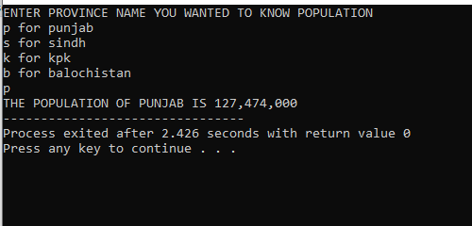

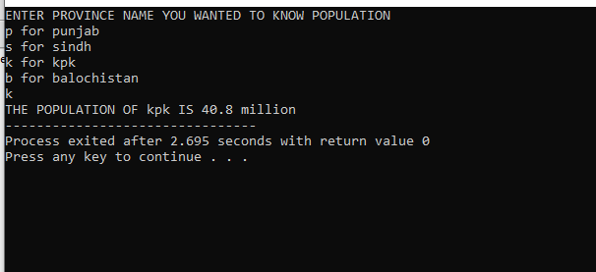

**SECOND PROGRAM**

#include<iostream>

using namespace std;

int main(){

char alphabet;

cout<<"ENTER ANY ALPHABET"<<endl;

cin>>alphabet;

switch(alphabet){

case 'a':

case 'e':

case 'i':

case 'o':

case 'u':

cout<<"IT IS VOWEL";

break;

default:

cout<<"IT IS CONSONANT";

}

}

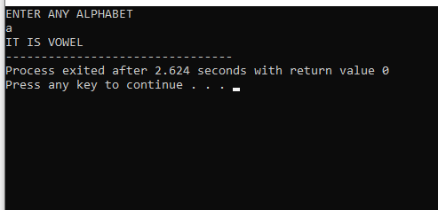

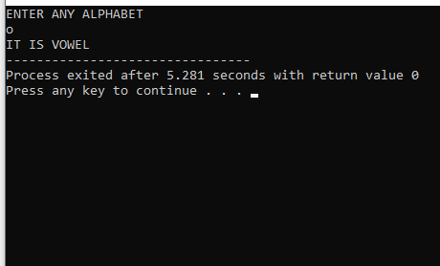

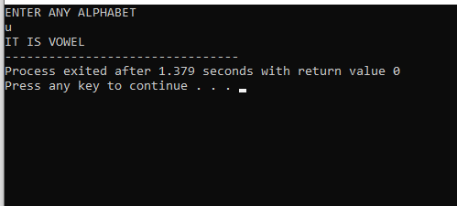

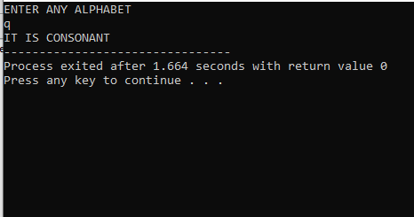

**THIRD PROGRAM**

#include<iostream>

using namespace std;

int main(){

int number;

cout<<"ENTER ANY NUMBER :"<<endl;

cin>>number;

switch (number>0){

case 1:

cout<<"THE NUMBER IS POSITIVE"<<endl;

break;

case 0:

switch(number<0){

case 1:

cout<<"THE NUMBER IS NEGATIVE"<<endl;

break;

case 0:

cout<<"THE NUMBER IS ZERO"<<endl;

break;

}

break;

}

return 0;

}

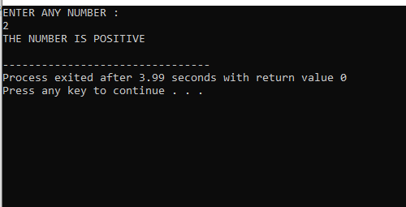

**FOURTH PROGRAM**

#include<iostream>

using namespace std;

int main(){

int a;

cout<<"ENTER YOUR AGE IN YEARS"<<endl;

cin>>a;

if(a>=20){

cout<<"YOU ARE ADULT";

} else {

if (a <=19 && a >=13){

cout<<"YOU ARE STILL TEENAGER";

} else {

cout<<"YOU ARE CHILD";

}

}

}

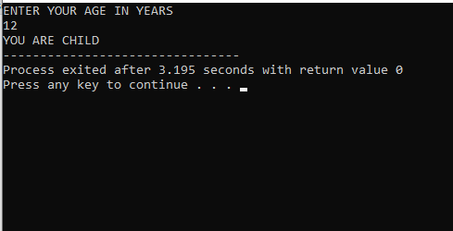

**FIFTH PROGRAM**

#include<iostream>

using namespace std;

int main(){

int m,n,b,greatest;

cout<<"ENTER FIRST NUMBER"<<endl;

cin>>m;

cout<<"ENTER THE SECOND NUMBER"<<endl;

cin>>n;

cout<<"ENTER THE THIRD NUMBER"<<endl;

cin>>b;

if (m > n) {

greatest = m;

} else {

if (n > b) {

greatest = n;

} else {

greatest = b;

}

}

cout << "The greatest number is: " << greatest << endl;

return 0;

}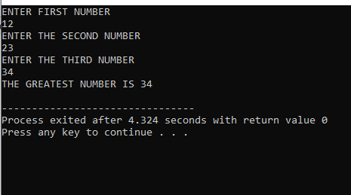

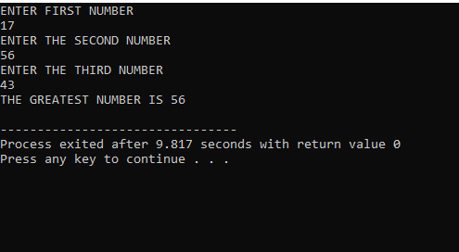

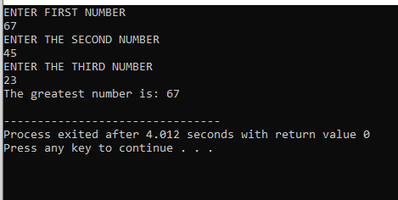

**SIXTH PROGRAM**

#include<iostream>

using namespace std;

int main(){

char alphabet;

cout<<"ENTER ANY ALPHABET"<<endl;

cin>>alphabet;

if(alphabet == 'a' || alphabet == 'e' || alphabet == 'i' || alphabet == 'o' || alphabet == 'u'){

cout<<"IT IS VOWEL";

} else {

cout<<"IT IS CONSONANT";

}

}



